Technical Design Document
Plan Media

Author | Rahul Tiwari
Company
Created | 2023-03-01

Version | Date | Author | Description
1 | 03-01-2023 | Rahul Tiwari | Initial version for HRDB database for Plan Media

Table of Contents

1 Introduction 2
2 Proposed Architecture 5
3 Assumptions 7

Introduction
The requirement from the business is to create the entire data warehouse and the reporting solution for the Human Resource department. Here the data is coming from CSV files and we need to move the entire legacy system (Old system) to MySQL and then the entire reporting needs to be done in the Tableau Desktop. Below are some of the details and proposal we have on the technicality’s aspect.

Current State Data Model
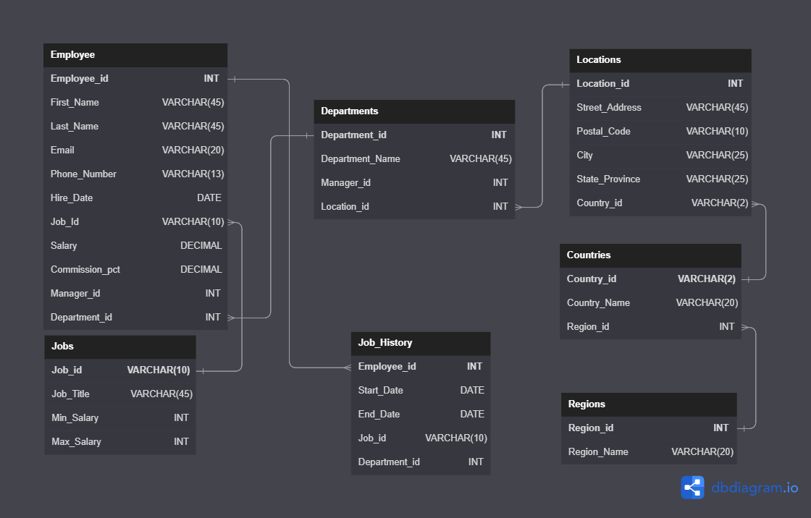

Current State Architecture
Job History
Employees
Departments
Locations
Countries
Regions
Job

Reporting in Excel

Proposed Architecture
Future State Data Model
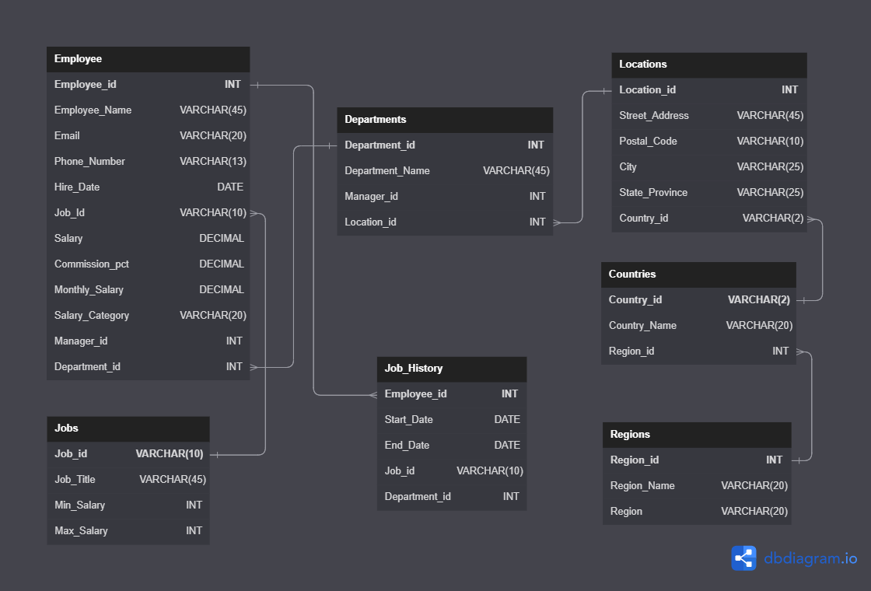

Future Stare Architecture

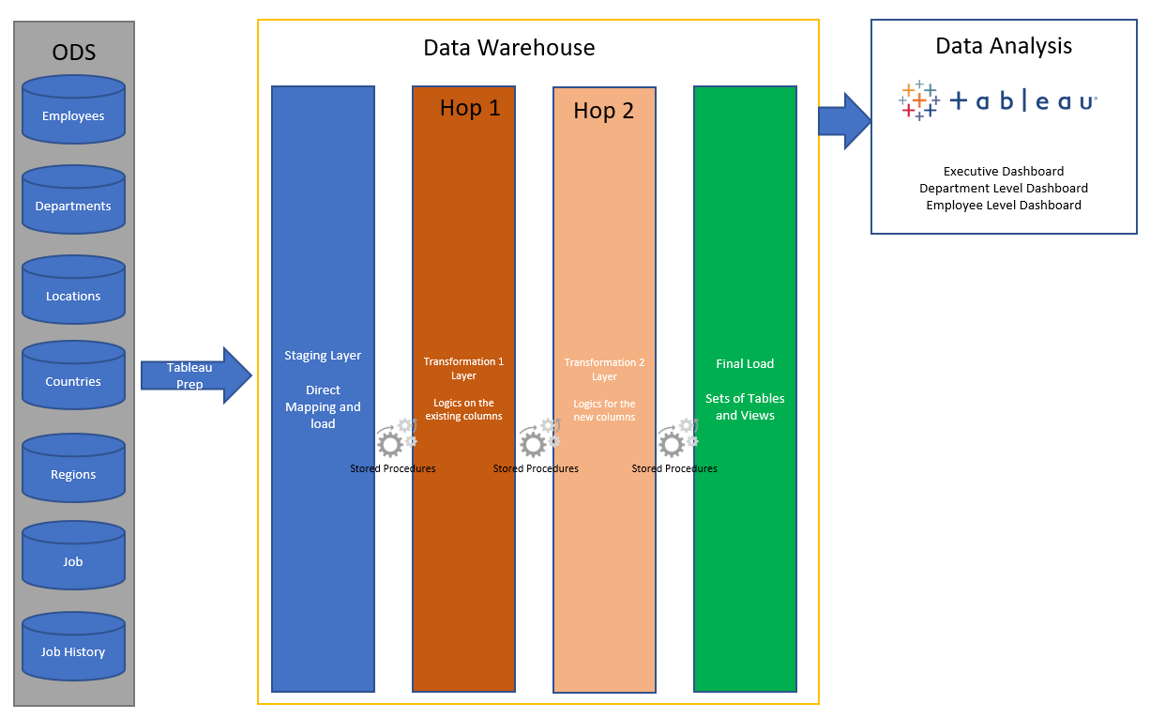

Assumptions
None of the tables are having history

